

CSA0902-Programming in Java

CO2 – AT2

Ashmi P S
192571004

1.Composite Numbers in Array
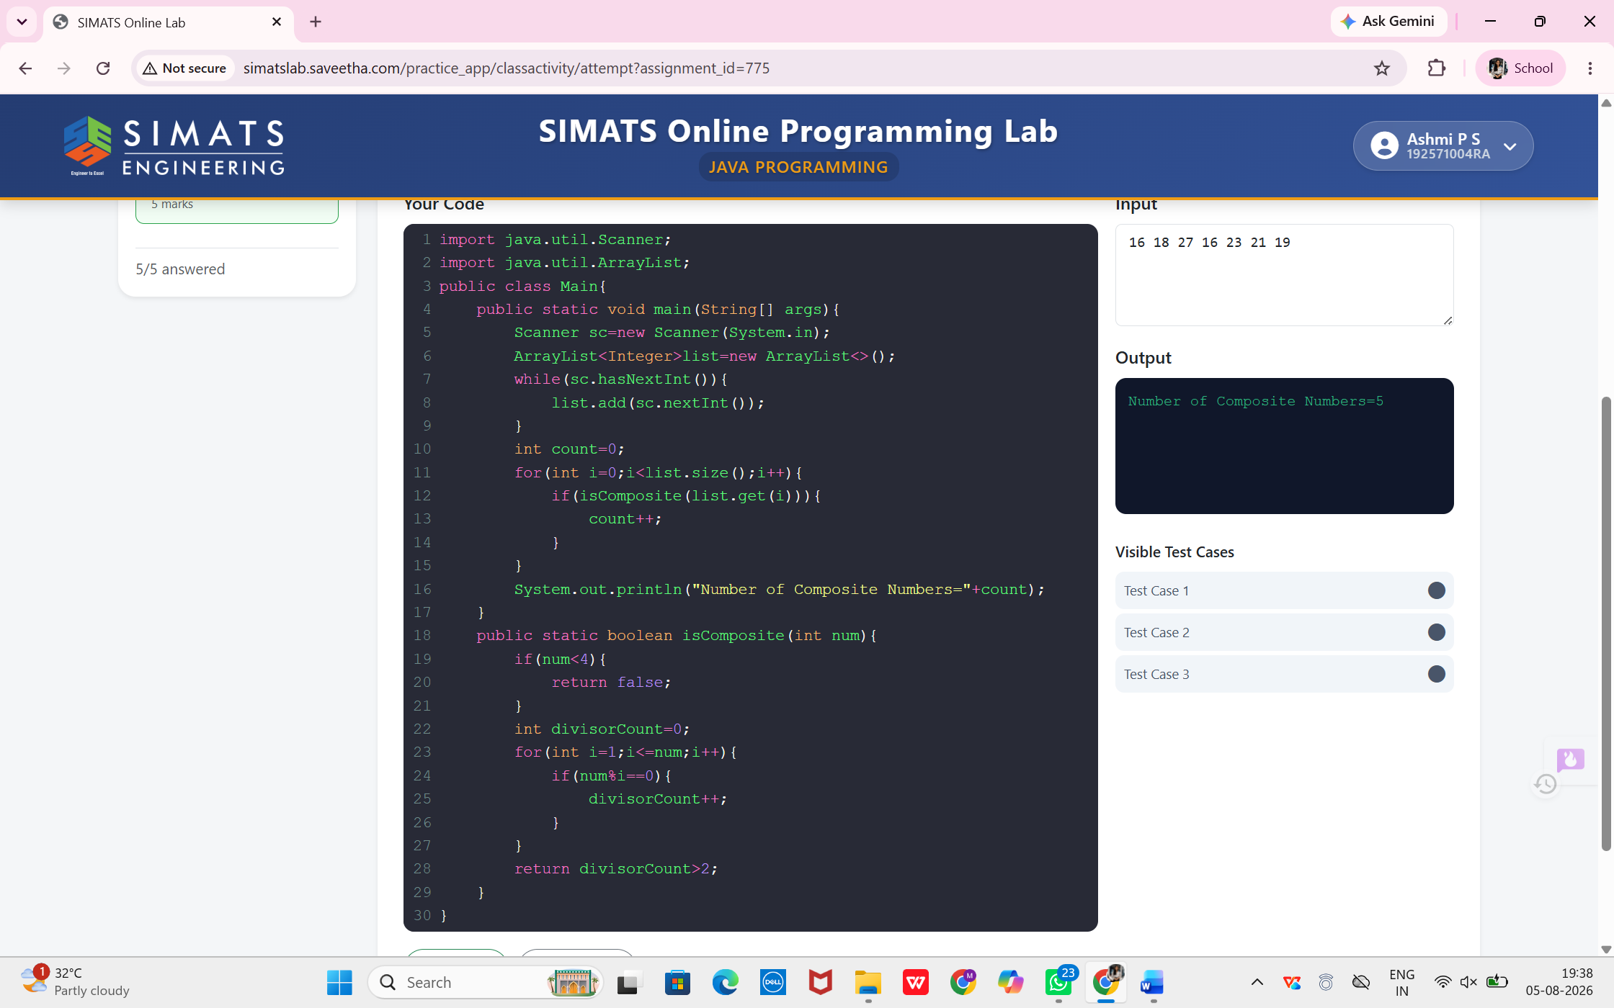

2.Skip K Numbers
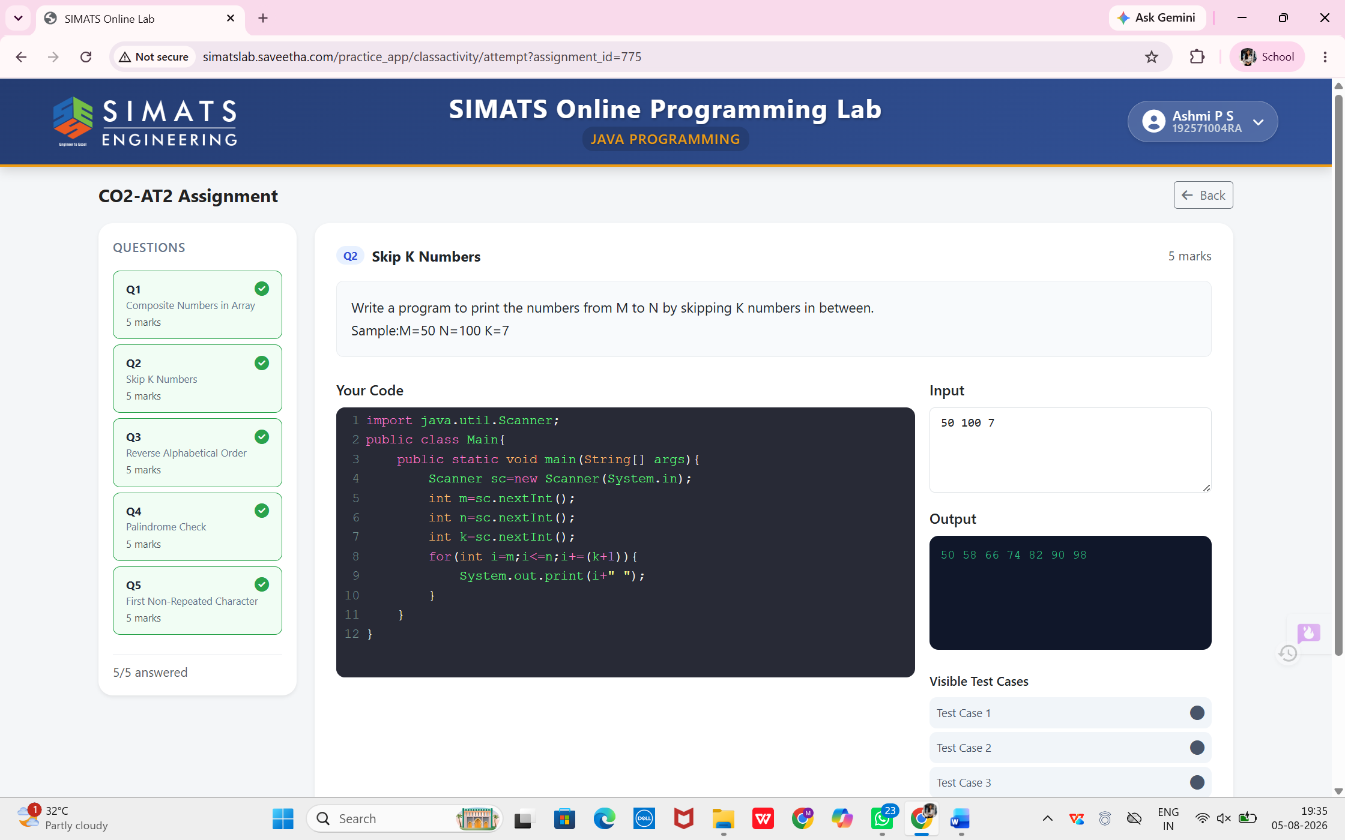

3.Reverse Alphabetical Order
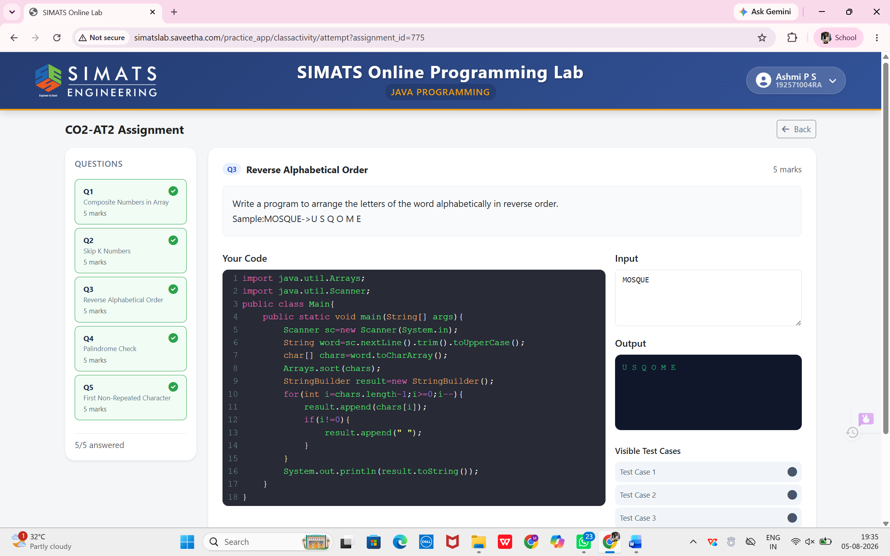

4.Palindrome Check
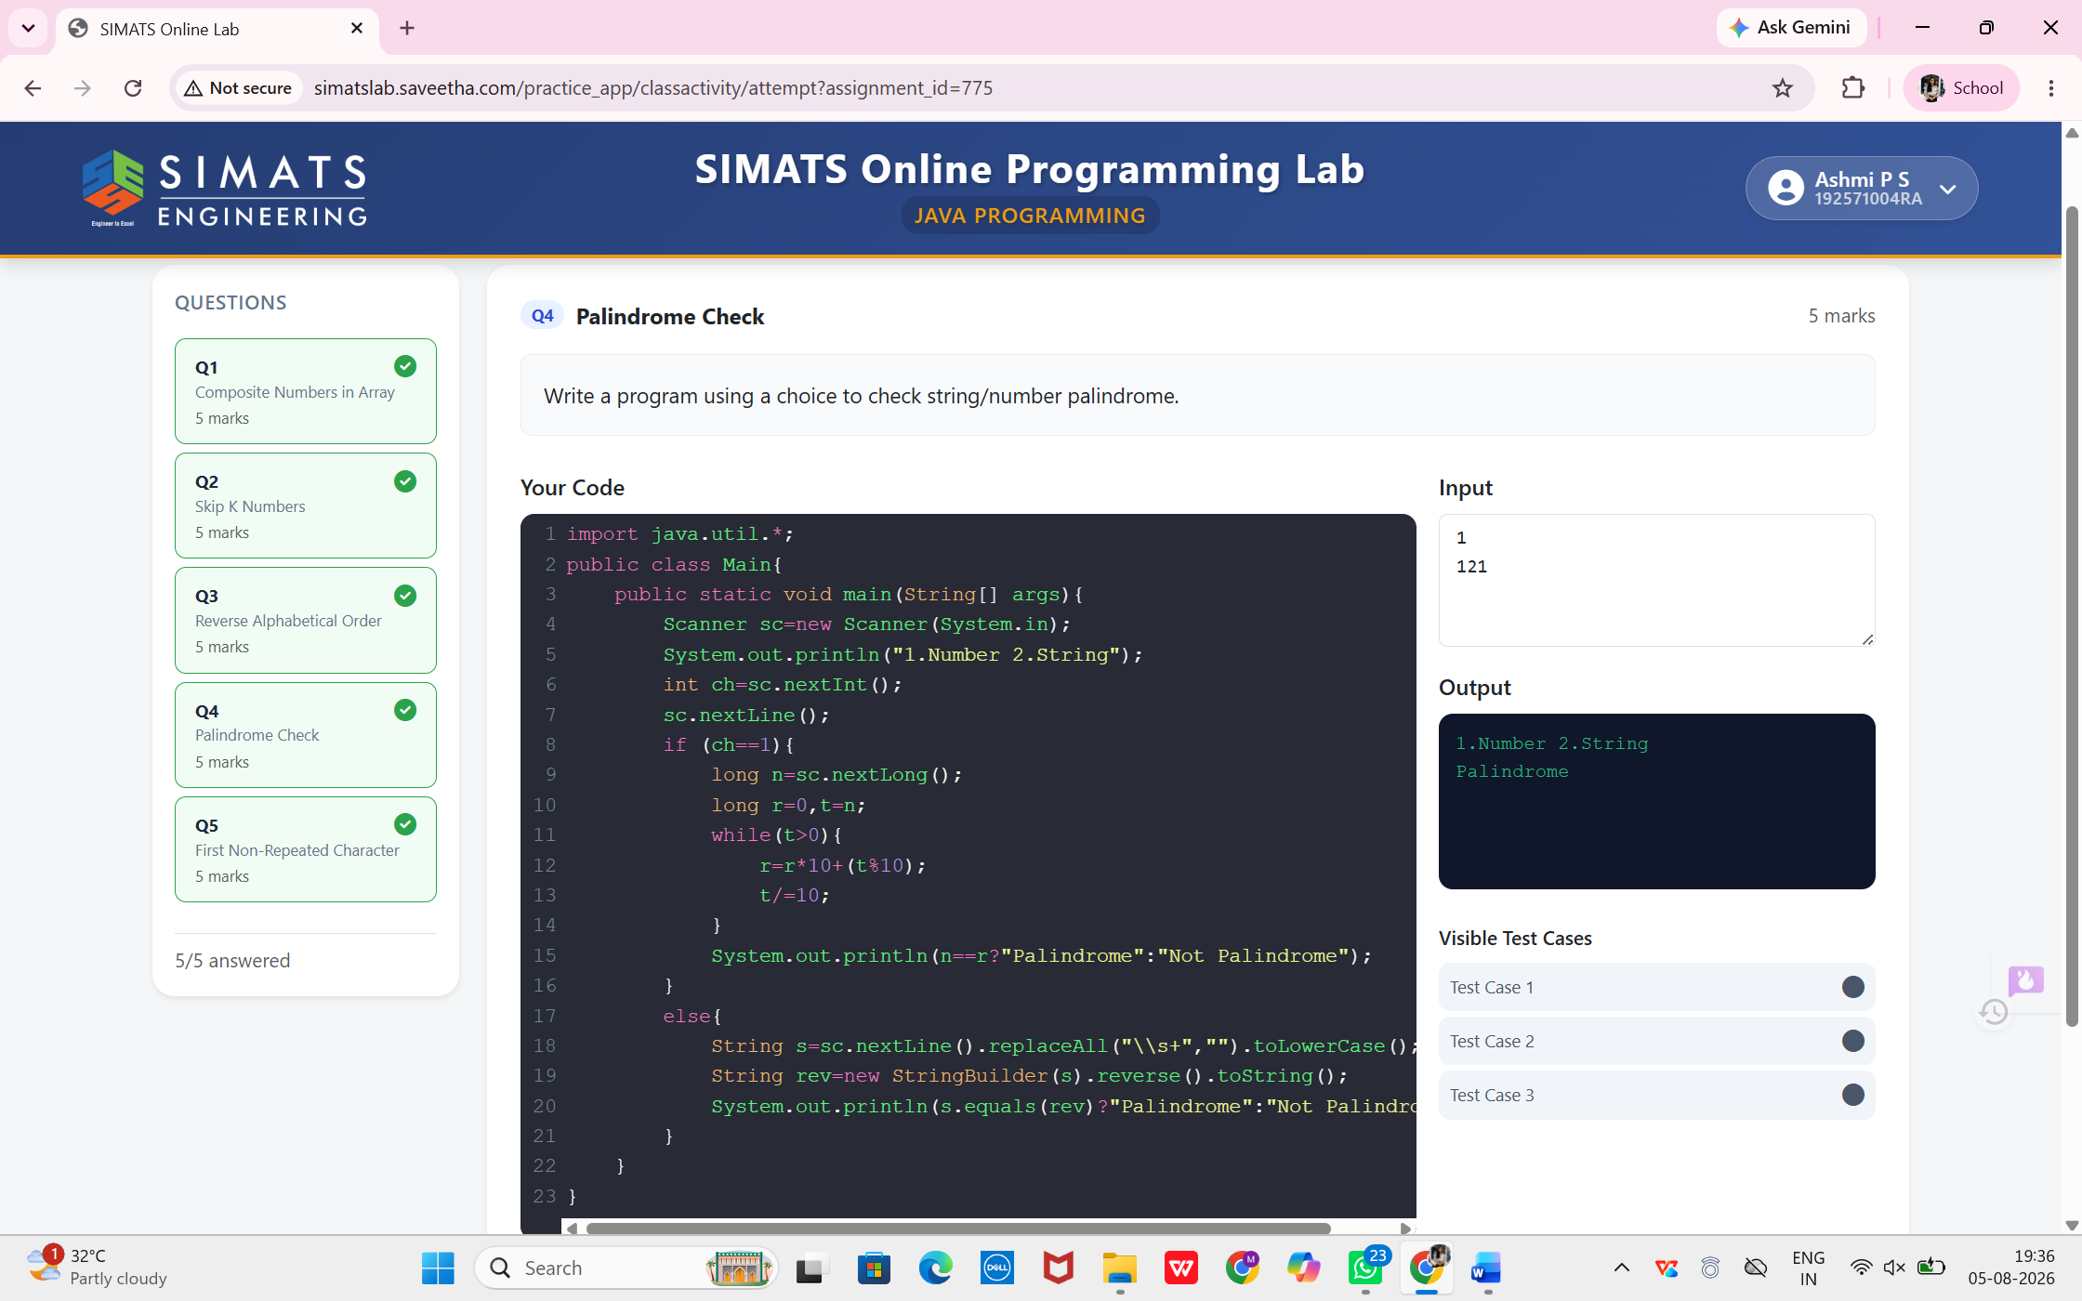

5. First Non-Repeated Character

